**Government Arts & Science College, Calicut**

**Palliative Care Unit**

**Activity report for the year 2018-19**

Teacher Coordinator : Dr. Muneer C.P(Dept. of Chemistry)

Members: Smt. Ragi(Dept. of English), Rejla(Dept. of Hindi), Subha(Dept. of Commerce)

Student Coordinators : Anusree II B.Sc. Maths & Somjith II B.Sc.Botany

1. **Selection of new student coordinators**

In the meeting held on 22.6.2018, Anusree II B.Sc. (Maths) and Somjith II B.Sc. ( Botany) were selected as the new student coordinators. Reja II BA (Economics) and Sida II BA (English) were given the charge of Home care and Skip a tea respectively.

1. **Enrolment of new volunteers**

New volunteers were enrolled from first year UG classes on 26.7.2018. Action plan for the current year was presented by Somjith.

1. **Skip a tea and ease a life**

In continuation to last year, charity was collected from students and staff of the college in different months, for the treatment of cancer patients of Institute of Palliative Medicine, Kozhikode. The amount handed over to IPMK was Rs. 6241/- on 27.7.2018 and Rs. 9623/- on 17.12.2018.

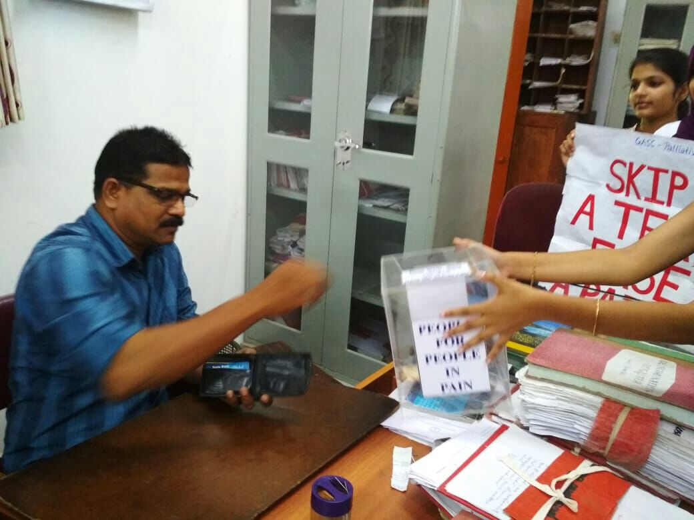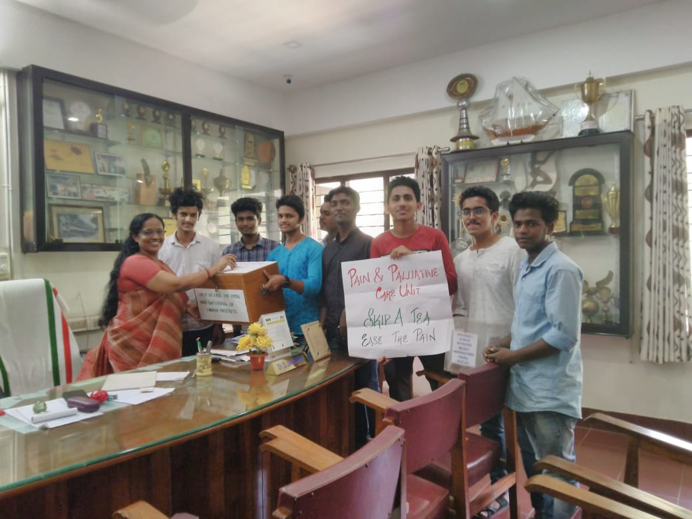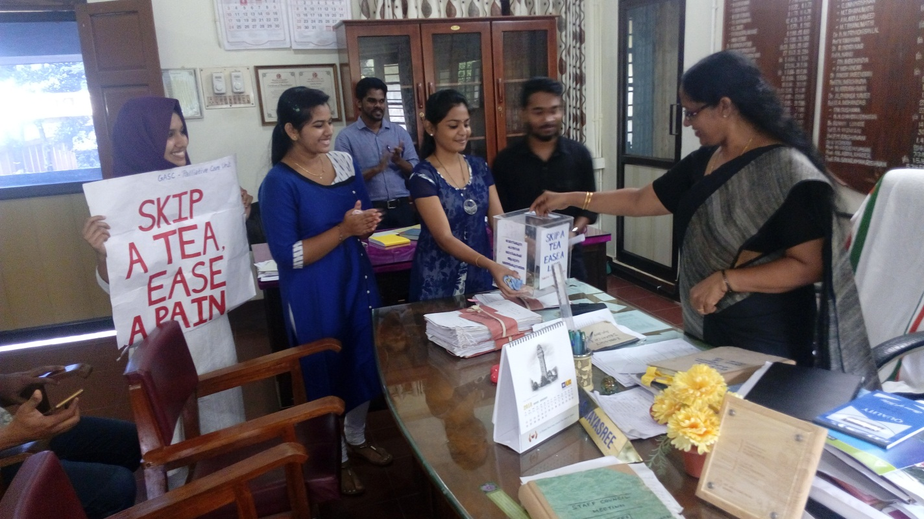

1. **Orientation Programme**

An Orientation Programme was organized on 3.8.2018 at 2pm, in the seminar hall. Dr. Jayasree(Principal) inaugurated the function. Dr. Abdul Gafoor, HOD of Dept. of Zoology and Convenor, Palliative Care Unit, Farook College took a class on “Palliative Care” and Mr. Vijayan C.K, HM, ELM School, Mukkam, took a class on “Antinarcotics”. 63 volunteers participated in the program.

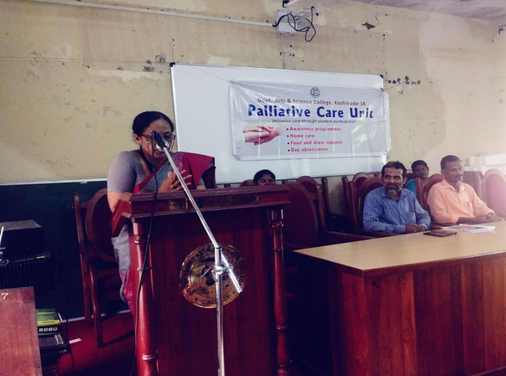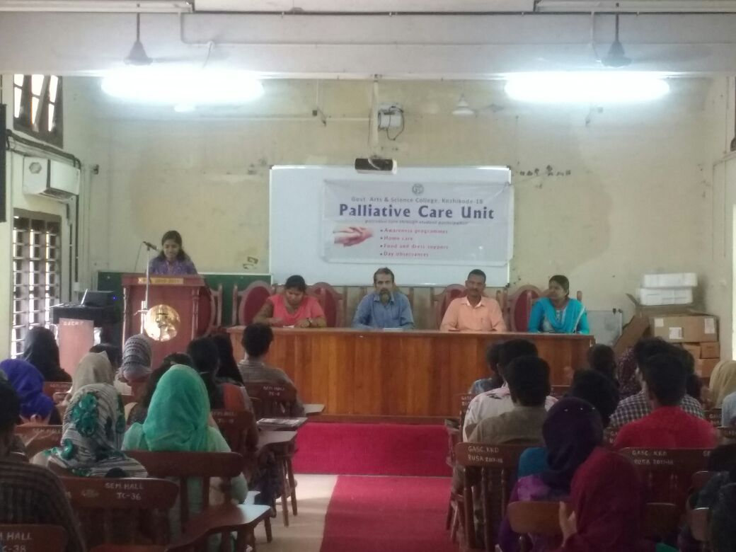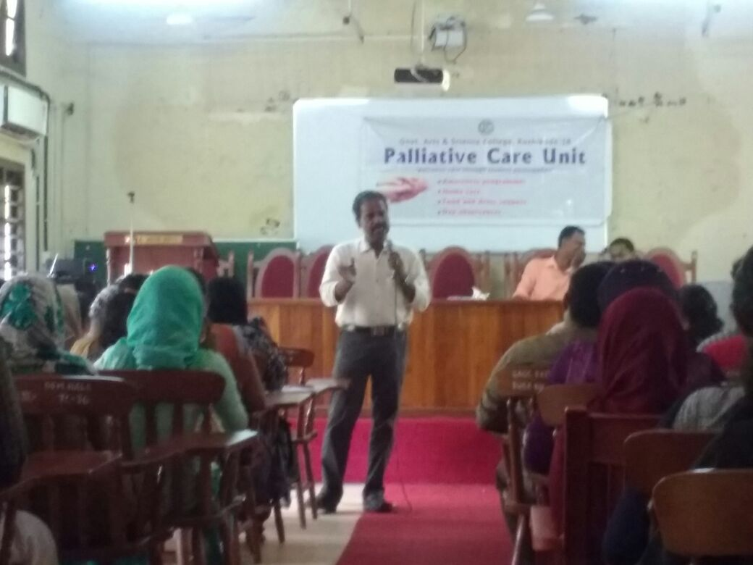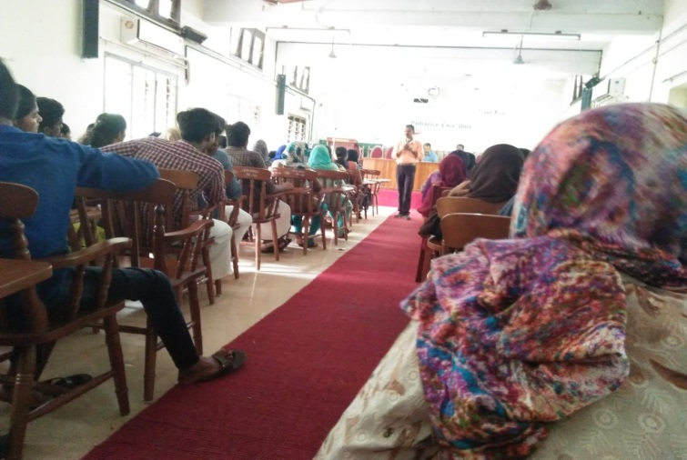

1. **Flood Relief Campaign**

Many of our volunteers attended various flood relief camps.

1. **World Palliative Day(October 14)**

In connection with World Palliative Day, a Home Care Training was conducted for our volunteers on 15.10.2018 in the Seminar Hall. A faculty from IPMK engaged the session. 75 volunteers participated in the program.

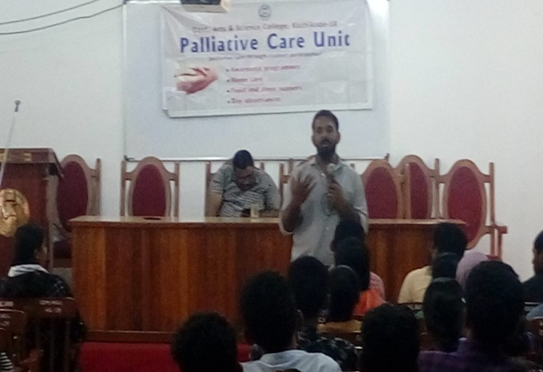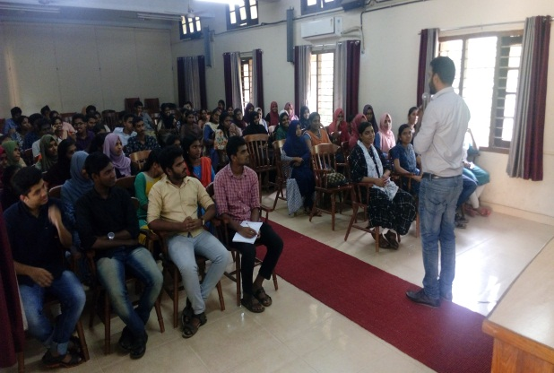

1. **Financial Assistance**

A fund raising campaign was organized to support the treatment of Aswin M Mohan, a UG student of IHRD College, Vazhakkad. An amount of Rs. 9271/- was handed over to his class mates by the Principal.

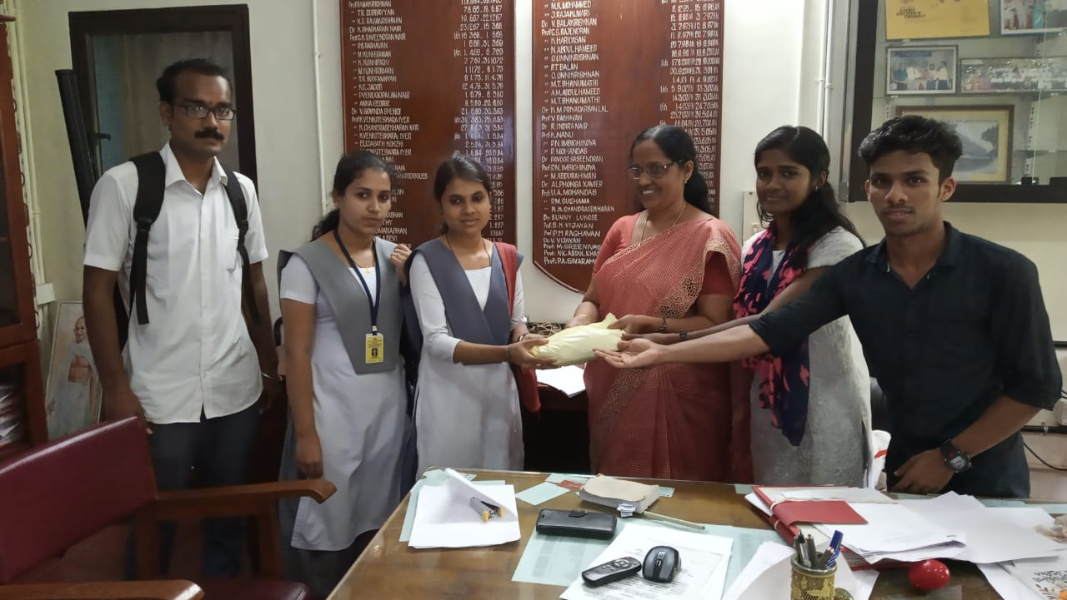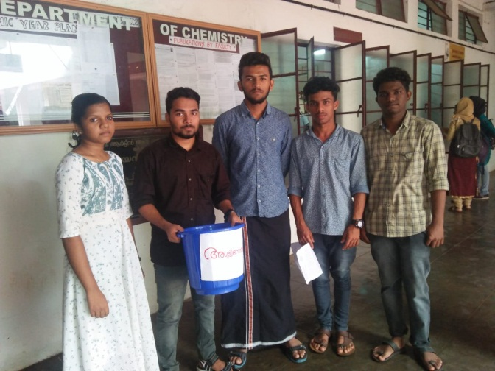

1. **Samvedanam**

60 volunteers attended a basic training programme, named “Samvedanam”, recognized by WHO, held on 10.11.2018 at IPMK. Certificate was issued to the participants.

1. **Hair Donation**

A few volunteers donated their hair for the benefit of cancer patients in the Hair donation campaign organized by UniCLT on 9, 10,11 November 2018.

1. **Palliative Care Day(January 15)**

Our students actively participated in various events organized by Sparam Palliative, Nadakkavu, in connection with Palliative Day Celebrations. 10 of our volunteers participated in the fund raising campaign on 15.1.2019 and 20 volunteers attended the program at Planetarium, Kozhikode. An appreciation letter was received from Sparsam Palliative Officials for the recommendable service rendered by our volunteers.

In collection with Palliative Day, a fund collection was organized in our campus on 25.1.2019, in order to support needy parents of our college. Rs. 6283/- was received.

1. **Socio-economic survey**

In continuation to last year’s survey, a socio-economic survey was conducted among the students of first UG and PG classes during the tutorial hour on 23.1.2019, in order to identify bed-ridden patients among parents. The scrutiny of the survey was done by our volunteers on 31.1.2019.

1. **Kaithiri**

Sri. Reeja, an active palliative volunteer on wheelchair, of Sparsam Palliative, Mukkam came to the campus to sell out paper pens made by palliative patients and to participate in an interactive session with the our volunteers on 1.2.2019. The program was inaugurated by the Principal. About 500 pens were sold out.

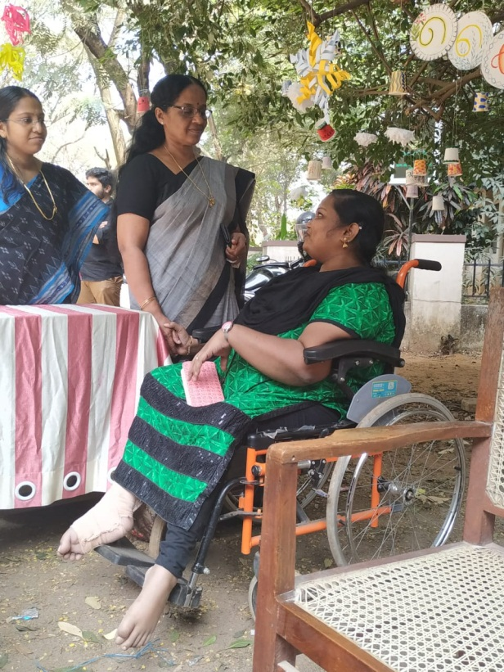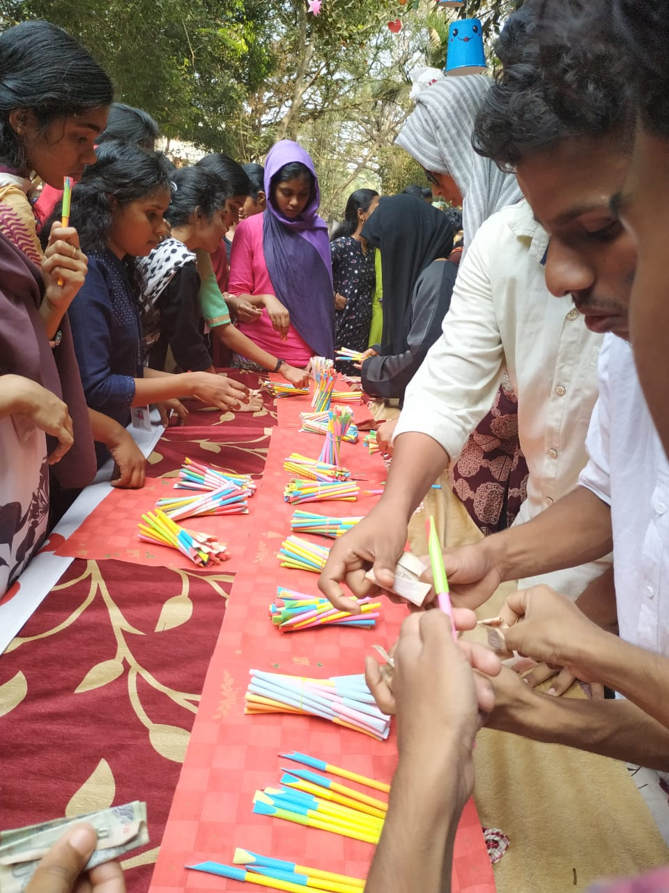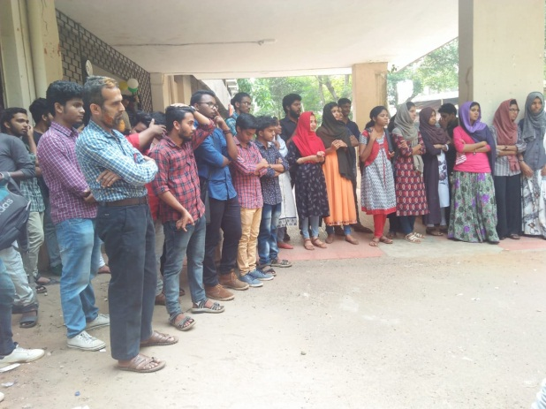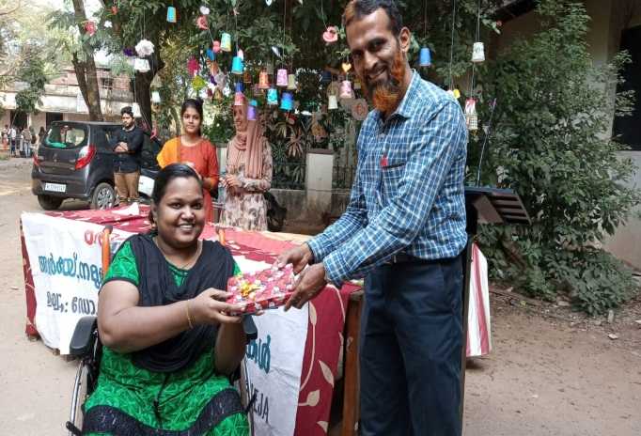

1. **Visit to Old age homes**

16 volunteers of our unit visited two old age homes namely “Mercy Home” at Vellimadukunnu and “We Smile” at Nadakkavu on 26.2.2019.